SIMATS ENGINEERING
ASSESSMENT TOOL 1: Concept Mapping

COURSE NAME: | Cloud Computing and Big Data Analytics | COURSE CODE: | CSA1522
Name | Kanmani L
Register Number | 192511414

COURSE OUTCOME COVERED
CO1: Apply cloud computing technologies including hardware-software evolution, virtualization, web services, and service models to develop cloud-based solutions. (BL2)
Assessment Tool Weightage: 20%

Dave's Taxonomy: Imitation (Level 1)  Question Count: 4 | Total Marks: 50

Code of Conduct
I _______Kanmani L(192511414)_____________ (Name / Reg. No) certify that this submission is my original work and that I have adhered to the guidelines specified for this assessment.
I understand that any violation of academic integrity rules will result in disciplinary action.
Signature of the student:
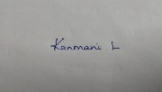

Assessment Tasks
Concept Mapping Tasks
Create concept maps for the following tasks. Each map must show key nodes, link labels, and a logical hierarchy.
- Concept Map 1: Cloud Computing Fundamentals. Include definition, characteristics, benefits, and limitations.
- Concept Map 2: Evolution of Cloud Computing. Connect hardware evolution, internet software evolution, distributed systems, and service delivery.
- Concept Map 3: Service Models. Map IaaS, PaaS, SaaS, and XaaS with provider responsibilities and user responsibilities.
- Concept Map 4: Virtualization and Web Services as Enablers of Cloud. Show how these two concepts support cloud deployment and scalability.
Expected concept nodes:
- Elasticity, scalability, resource pooling, on-demand access, measured service
- Virtual machine, hypervisor, abstraction, API, SOAP, REST, provider, consumer
- Infrastructure layer, platform layer, application layer, shared responsibility

Concept Mapping Rubric

Criteria | Weightage | Level 4 - Exemplary | Level 3 - Proficient | Level 2 - Developing | Level 1 - Beginning
Concept Identification | 25% | All major concepts are accurately identified | Most concepts are identified correctly | Limited concepts are identified | Essential concepts are missing
Relationship Mapping | 25% | Links between concepts are accurate and meaningful | Most links are correct | Some links are weak or unclear | Relationships are mostly incorrect
Hierarchy and Organization | 20% | Excellent structure with clear hierarchy | Mostly organized with minor issues | Basic structure with weak hierarchy | No logical organization
Technical Relevance | 20% | Map strongly reflects cloud course content | Mostly aligned to topic | Partially aligned to topic | Weak alignment to topic
Visual Clarity | 10% | Neat, readable, and easy to interpret | Generally readable | Somewhat cluttered | Poorly presented

5. Questions
i). Evaluate the effectiveness of your concept map in representing cloud computing principles. Which design decisions most strongly support your solution, and why?
ii). Analyze how scalability, elasticity, and resource management influence the architecture shown in your concept map. What challenges could arise if these capabilities were absent?
iii). Justify the selection of the APIs, web services, or cloud services included in your concept map. How do they contribute to the overall functionality and efficiency of the system?
iv). Critically examine the relationships between the components in your concept map. How do these interactions improve reliability, performance, or user experience?
v). Reflect on the process of developing your concept map. How has creating and analyzing the map changed your understanding of cloud computing architecture, and what improvements would you make if you were redesigning it?

Concept Map 1: Cloud Computing Fundamentals. Include definition, characteristics, benefits, and limitations.

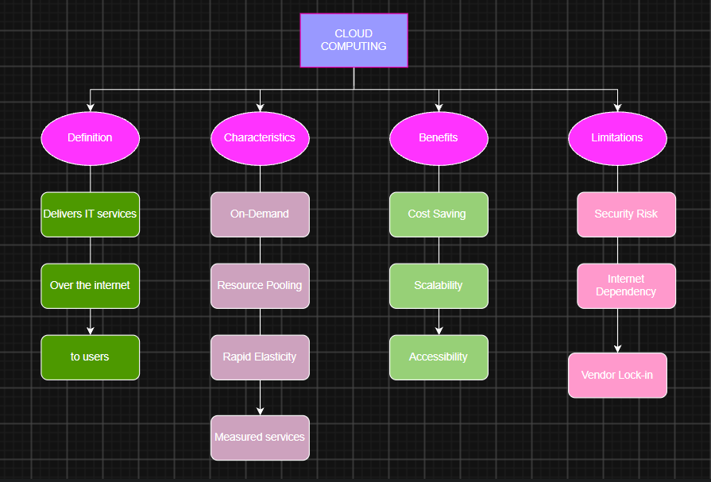

Concept Map 2: Evolution of Cloud Computing. Connect hardware evolution, internet software evolution, distributed systems, and service delivery.

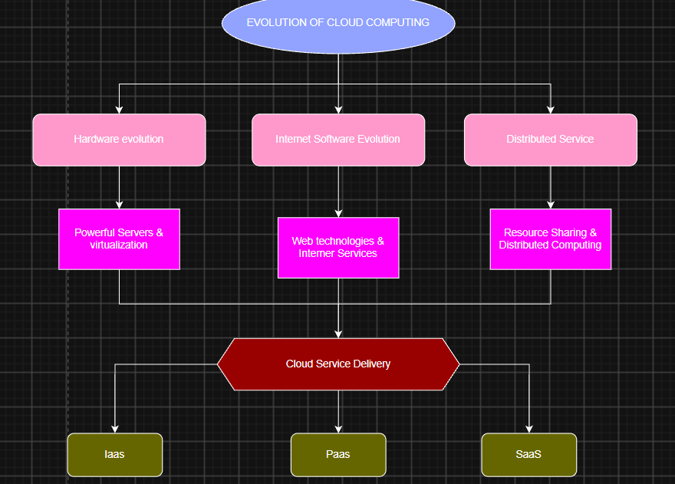

Concept Map 3: Service Models. Map IaaS, PaaS, SaaS, and XaaS with provider responsibilities and user responsibilities.

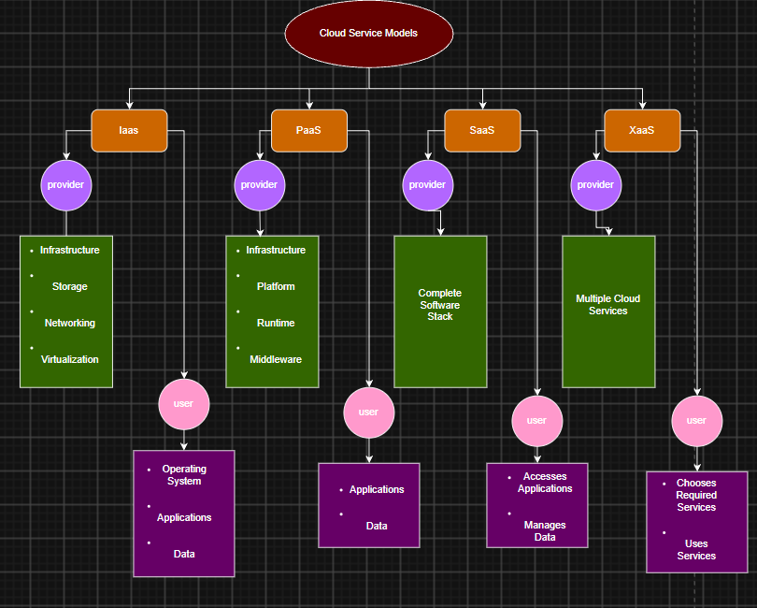

Concept Map 4: Virtualization and Web Services as Enablers of Cloud. Show how these two concepts support cloud deployment and scalability.
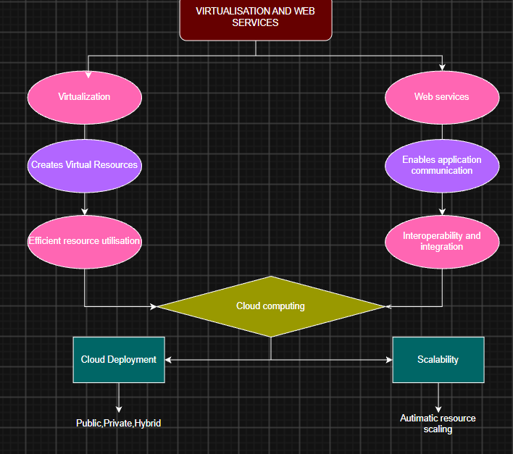

(i)Evaluate the effectiveness of your concept map in representing cloud computing principles. Which design decisions most strongly support your solution, and why?

Answer: The concept map effectively represents cloud computing by organizing key concepts in a clear hierarchy. Placing cloud computing at the center and connecting related components improves understanding and shows how they work together.

ii). Analyze how scalability, elasticity, and resource management influence the architecture shown in your concept map. What challenges could arise if these capabilities were absent?
Answer: Scalability, elasticity, and resource management ensure efficient resource allocation, high performance, and cost optimization. Without them, the system may face slow performance, resource wastage, and reduced reliability.

iii). Justify the selection of the APIs, web services, or cloud services included in your concept map. How do they contribute to the overall functionality and efficiency of the system?
Answer: APIs enable communication between applications, web services support data exchange, and cloud services provide computing resources. Together, they improve integration, flexibility, and overall system efficiency.
iv). Critically examine the relationships between the components in your concept map. How do these interactions improve reliability, performance, or user experience?

Answer: The components work together to improve reliability, performance, and user experience. Virtualization enables cloud services, while APIs, web services, and resource management ensure smooth communication and efficient operations.
v). Reflect on the process of developing your concept map. How has creating and analyzing the map changed your understanding of cloud computing architecture, and what improvements would you make if you were redesigning it?

Answer: Creating the concept map improved my understanding of cloud computing architecture and the relationships between its components. If redesigned, I would include security, load balancing, and fault tolerance for a more comprehensive view.

